SUMMER READING PALS
- - OUR CORNER- -
THE HOUSING AUTHORITY OF AMERICUS NEWSLETTER
“Building Bridges For Better Communication”

JULY 2022

2022
“Moving Beyond the Pandemic”

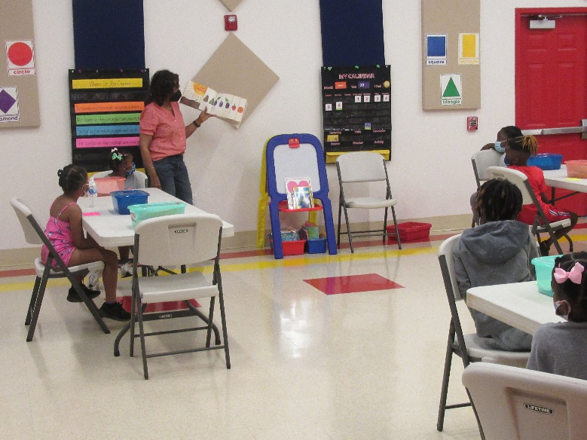
“A teacher affects eternity; you can never tell
where her influence stops.”

After being postponed for the past two years due to the Covid 19 Health Crisis, the Summer Reading Pals Program resumed operation this summer. It was time to move beyond the pandemic.

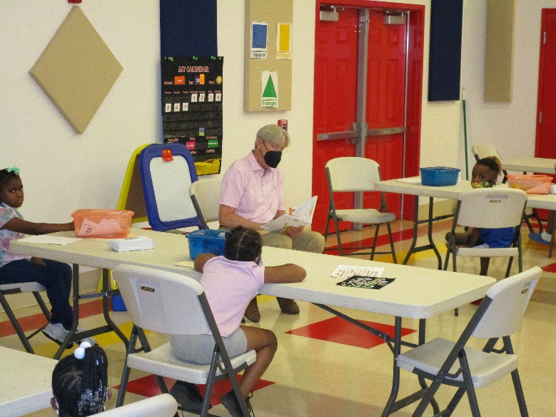
“Reading Pals listen closely to a story being read
by Guest Reader, Commissioner Ricky Arnold.”

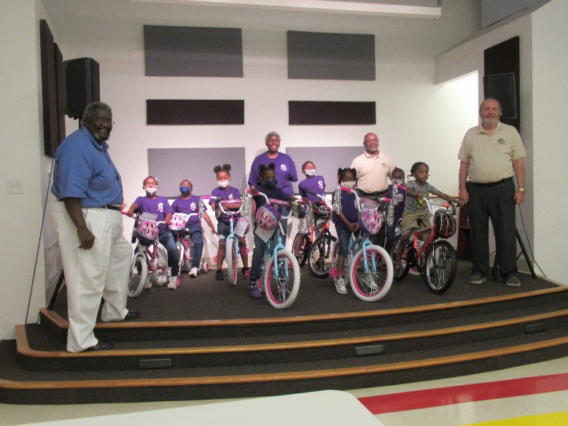
“Our fingerprints don’t fade from the lives we touch.”

Even with there being an increase in the number of positive cases in our area, 16 brave 1st & 2nd graders forged ahead and had as much fun as they could possibly stand from June 7th to June 30th at the John C. Anderson Community Building. The young readers had an awesome time working on a variety of learning activities that focused primarily on reading and math skills. They also worked on several arts and crafts projects that were themed around summer vacation destinations and different beach animals.

Retired Educator, Ms. Sandra Mitchell was ready to return to the classroom with our children. She said that many children had fallen behind in a lot of their basic learning skills during the pandemic and that it would be very hard, if not impossible, to make up for that learning loss. Ms. Mitchell was grateful to the Housing Authority for thinking about the children and starting the Summer Reading Pals Program back up. Ms. Mitchell, along with Resident Services Coordinator Diana Roberts, were very pleased with the attendance. Both are confident that the number of young participants will increase next summer, provided we do not encounter another health crisis of pandemic proportion.

CONTINUED ON PAGE 4
HELLO RESIDENTS:

Mr. George F. Edge, Chief Executive Officer

The RAD (Rental Assistance Demonstration) Conversion process is all complete as of May 2022. I want to again THANK YOU for your enormous cooperation during the conversion process. We are officially operating under a new division of HUD, which is called the Multi-Family.

We will be further exploring this program to see how operational procedures can be improved upon for our residents and our staff. For instance, we are exploring the possibility of revising our recertification dates so they will be in alignment with the Multi-Family Division, which recognizes anniversary dates as the recertification date. This will mean that you will be recertified in a different month than what you have grown accustom to.

Also, let me encourage you to report any changes in income or family composition within ten (10) days of its occurrence. If you fail to do this, it could have a severe impact on the rental amount you are required to pay. Changes in composition consist of things like marriage, new born children, or someone moving in or out of your unit. It is our responsibility to make sure that you are occupying the correct bedroom size unit.

We recently concluded our Summer Reading Pals Program. This is a summer reading opportunity for school age children to enhance their reading and math skills through reading and being read to. This year we were able to award the participants with a new bicycle, safety gear, and a lock. Next year, it is our goal to increase the participation, because it has been proven that children who read or is read to benefit greatly in the following areas.

- Improved ability to think and understand
- Improved language skills
- Academic success
- Increased concentration and discipline
- Improved imagination and creativity

Please consider allowing your child to participate in Summer Reading Pals 2023 (June 5 – June 29, 2023).

Finally, due to the rise in positive COVID test results in Sumter County, and in an effort to keep our employees and you (our residents) safe, we are asking the following:

- If you or a member of your family are in quarantine, PLEASE DO NOT REPORT maintenance work orders except for extreme emergencies. Extreme emergencies are defined as water leaks, drain backups, electrical issues such as shortages, air conditioning if the temp is above 90 degrees inside the apartment in the summer, and 40 degrees or below in the winter.

- If you have traveled and are not feeling well, PLEASE DO NOT REPORT maintenance work orders except for extreme emergencies.

For any and all other maintenance requests, please wait until your household has been released from quarantine.

Further, I want to encourage you to continue to wash your hands often. Use soap and water for at least 20 seconds; especially if you are in a public place, or after blowing your nose, coughing, or sneezing.

Please stay safe!!

George F. Edge, CEO
“Without you there will be no me.”

Page 2

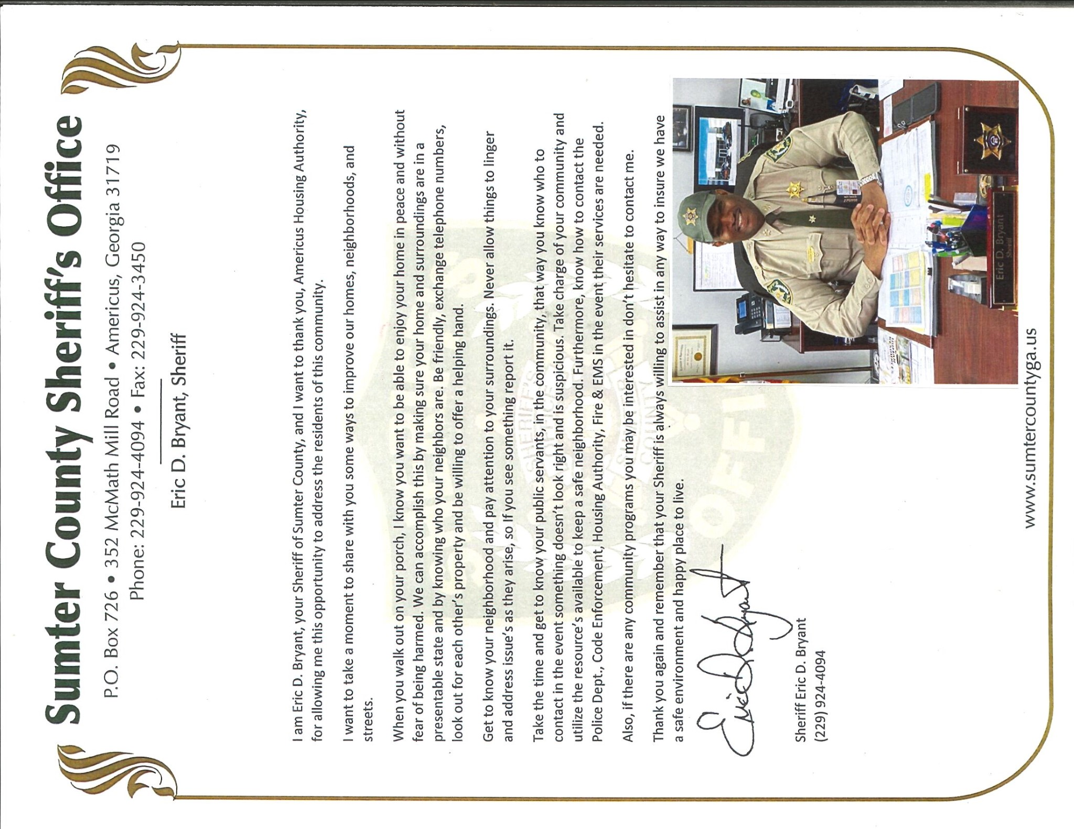
Page 3
Page 3

Summer Reading Pals 2022

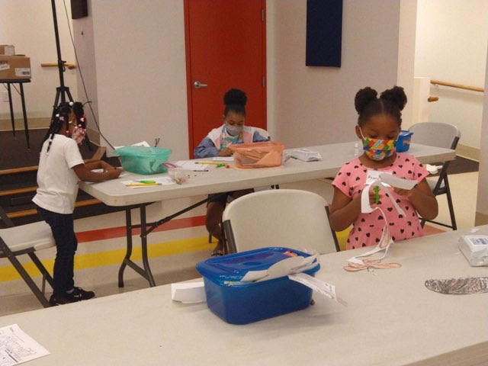
“Every expert was once a beginner.”
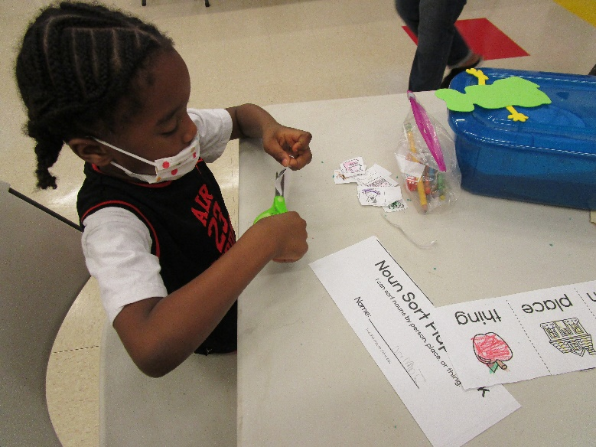
“Reading is to the mind
what exercise is to the body.”

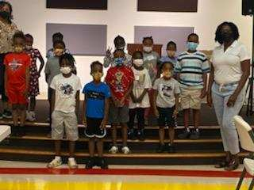
Commissioner Jessica Wright stopped by to
be a Guest Reader for the Summer Reading Pals.
The Americus Housing Authority presented a new bicycle, complete with helmets and bicycle locks to each child that attended the program. Mr. George Edge, CEO and the Housing Authority Board of Commissioners agreed the new bicycles would be a great incentive for perfect attendance. The bicycles were also a show of appreciation to the parents for releasing their children to be participants in our first Summer Reading Pals Program since the onset of the pandemic. It was impossible to tell who was most excited about the new bicycles on the last day of class; the children or the parents. The bicycles were delivered to the homes by maintenance personnel; as the young readers returned home on the bus.

SPECIAL THANKS to Mr. Gary Woods, our Manager of Maintenance, and his wife, Mrs. Sharon Woods (previous owners of their own bicycle shop) for putting all 16 of the bicycles together for the children. The two of them did an absolutely amazing job!!!

Also, SPECIAL THANKS to the members of the Housing Authority Board of Commissioners who took time out from their busy schedules to come and be Guest Readers for our Summer Reading Pals. They were Commissioners Ricky Arnold, Bill Krenson, and Jessica Wright.

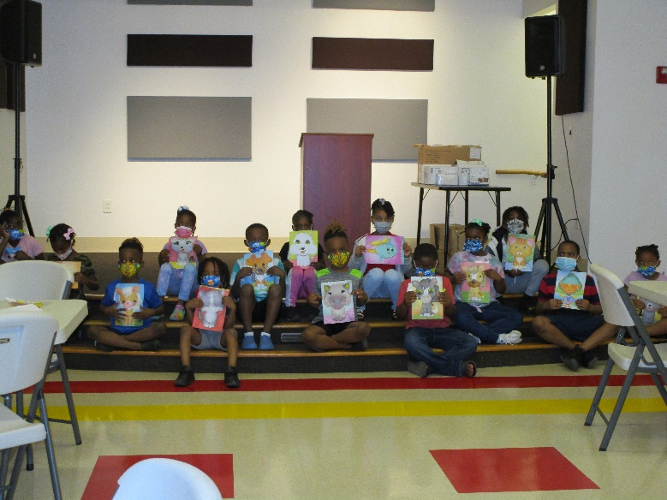
TELL ME and I may forget;
TEACH ME and I will remember,
INVOLVE ME and I will learn.

So go ahead and Mark The Date for Summer Reading Pals 2023 (June 5th thru June 29th).

For more information or to share ideas , please contact Diana Roberts, Resident Services Coordinator at (229) 924-3386, Ext. 240.
Page 4

GAHRA SCHOLARSHIP
WINNERS

The Americus Housing Authority is pleased to announce the recipients of both the Adult and High School Scholarship Awards. The scholarships were presented at the Scholarship Luncheon that was part of GAHRA (Georgia Association of Housing and Redevelopment Authorities) Annual Spring Conference that was held in Jekyll Island, GA. There were high school and adult students competing for the various scholarship awards from housing authorities all over the State of Georgia.

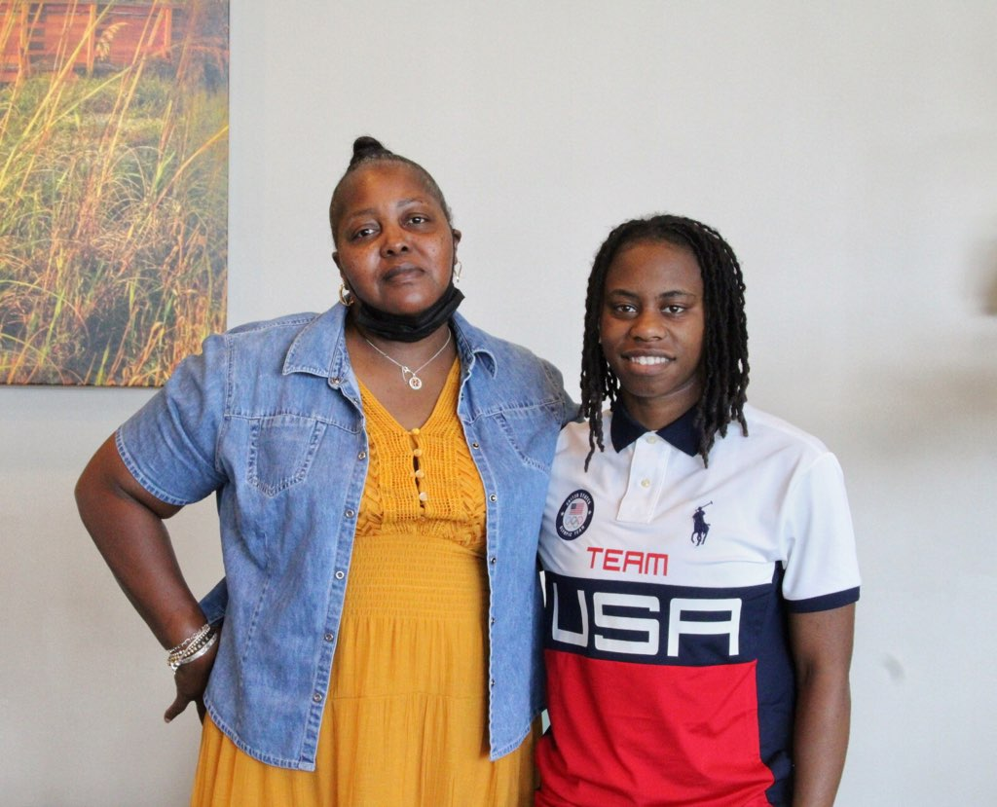
Amy Gary (Adult Winner) & Tiffany Goodman (High School Winner)

Winner in the Adult Scholarship Category was Amy Gary. After working as a CNA (Certified Nursing Assistant), Amy decided to return to school to become a Professional Counselor. Amy is currently a sophomore at Georgia Southwestern State University with an anticipated graduation date of December 2024. Amy received a one-time scholarship in the amount of $2,000.00. Congratulations Ms. Amy Gary!!!

Tiffany Goodman was the High School Scholarship winner. Tiffany was a member of the 2020-2021 Sumter County Varsity Girls Basketball Team. As a credit to Tiffany’s phenomenal basketball skills, she and 5 other girls which made up the “entire team” won their Regional Basketball Championship. Tiffany will be attending Gordon State College in Barnesville, GA where she will be a welcomed asset to their basketball team. We look forward to sharing great things from Tiffany both in the classroom and on the basketball court. Tiffany received a $4,000 scholarship to be distributed over the next 4 years in the amount of $1.000.00 per year. Congratulations Tiffany Goodman!!!
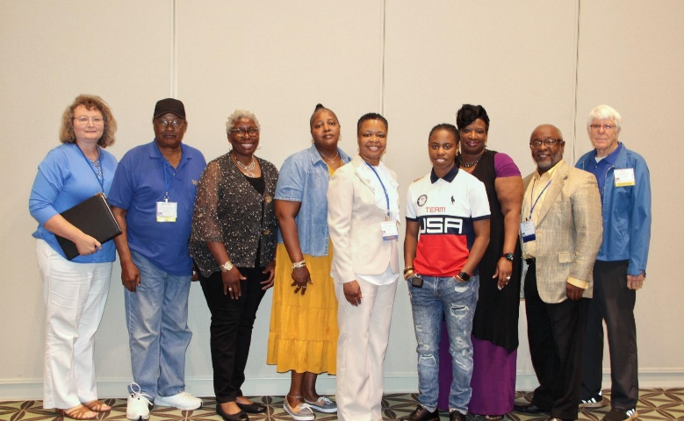
L-R: Shelia DeLoach, Dwight Chavis, Diana Roberts, Amy Gary, LaTonya Simmons, Tiffany Goodman, Korene Davis, George Edge, and Bill Krenson

We encourage all our adult and high school students to strive to do their very best in the field of academics and extracurricular school & community activities. GAHRA will be offering these and other scholarship opportunities during the new school year as well.

****************************************

SPRING 2022 DEAN’S LIST ANNOUNCED AT
GEORGIA STATE UNIVERSITY

The Americus Housing Authority is pleased to announce that our 2021 High School Scholarship Winner, De’Reginae Mercer, was named to the Dean’s List at Georgia State University in Atlanta. De’Reginae is currently enrolled at Georgia State where she is pursuing a degree in Public Health. Her ultimate goal is to become a renowned advocate in the Public Health arena.

To be eligible for the Dean’s List, degree-seeking students must have earned a Grade Point Average (GPA) of at least 3.5 for a minimum of nine semester hours of academic credit taken at Georgia State during the fall or spring term with no incompletes for the semester.

Congratulations De’Reginae Mercer!!! Keep up the good work.
EDUCATION IS ONE THING THAT NO ONE CAN TAKE AWAY FROM YOU.
Page 5
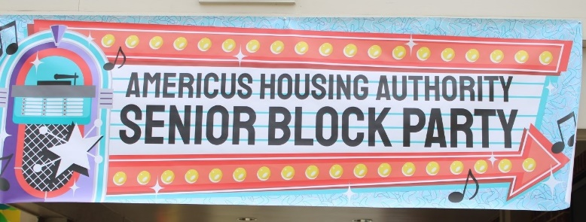
Moving Beyond The Pandemic

The seniors of the Americus Housing Authority were ready to shed the heavy weight of the Covid-19 pandemic. What better way to reunite the seniors than with a SENIOR BLOCK PARTY? This was the very first event for the seniors since 2019. The senior tenant population is very much appreciated at the Americus Housing Authority.

The event was held at the John C. Anderson Community Building. Mrs. Suleania Bryant of Only Imagine transformed the atmosphere, both inside and outside, into the Land of Luau. Excitement was in the air as the seniors began to arrive and see faces they had not seen in a long, long time. Mrs. Roberts was especially happy to see so many of her Senior Bingo Club babies at the Senior Block Party.

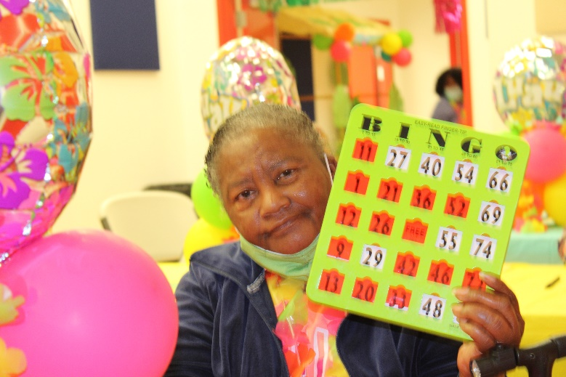
It’s BINGO for Ms. Daisy White.

The seniors had a wonderful time of fun, food, prizes, and fellowship. Sack lunches consisted of freshly grilled hot dogs and hamburgers prepared by the Housing Authority staff. The seniors enjoyed playing games The Price Is Right and Name That Tune. For many of the seniors that do not go shopping on a regular basis, The Price Is Right was very challenging. The current prices of everyday household items have increased tremendously. Name That Tune is always a group favorite. Nothing can restore memory in seniors like a familiar song from the past.
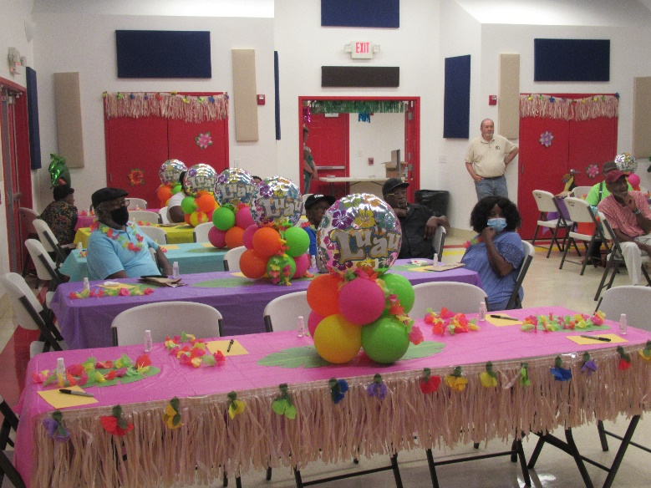
The room was beautifully decorated with
many festive colors.

Mr. Terry Clark, owner of Market Produce in Moultrie, GA brought over 75 food bags for the seniors. Each bag consisted of fresh cabbages, sweet potatoes, onions, strawberries, oranges, and other fruits and vegetables.
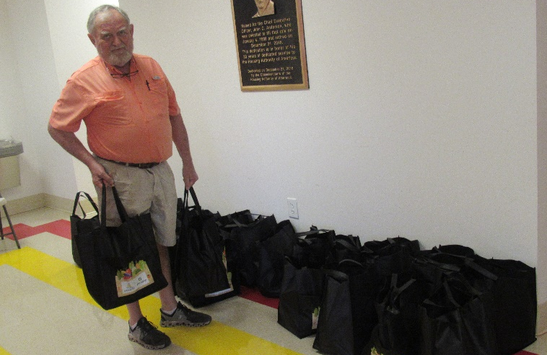
Mr. Terry Clark, owner of Market Produce,
Moultrie, GA

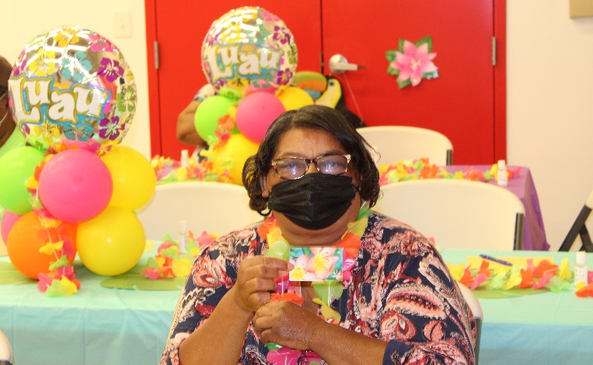
Ms. Etta McDonald won a gift card.
Page 6

“SWEEP OUR
NEIGHBORHOOD DAY”
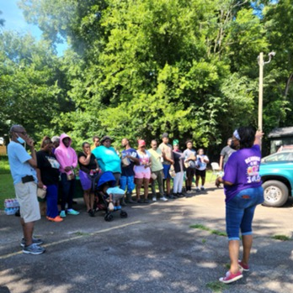
Mrs. Sharon Haugabook (PH Project Manager) speaks to the residents

Residents of the Forrest Street area came together for a SWEEP OUR NEIGHBORHOOD DAY, organized by Mrs. Sharon Haugabook, Public Housing Project Manager. The residents came out in unity and did a great job cleaning up the area; from the front streets, to the sidewalks, to the fencings, to the dumpster area, and to the laundry room.

The Housing Authority provided shovels, rakes, gloves, trash bags, face masks, hand sanitizers, and hand wipes; along with sack lunches consisting of grilled hot dogs, hamburgers, chips, and beverages.

McKessia Reese & her sons moved discarded bed mattresses to the street for proper pickup.
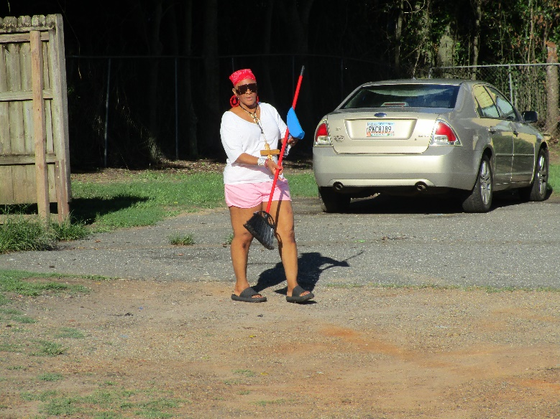
Teressa Wooten helped to sweep the parking lot.

Mrs. Haugabook thanked the residents for helping to make the event a huge success. She said some other great things are planned and are on the way in the future.

- New Parking Lines
- New Back Fencing
- Cameras for the Dumpster & Laundry Site
- Lettering to Identify Buildings
- Paving / Filling Holes in the Parking Lot

SPECIAL THANKS to Mr. Carl Edmonds Sr. for coming out to cut the grass in the area.

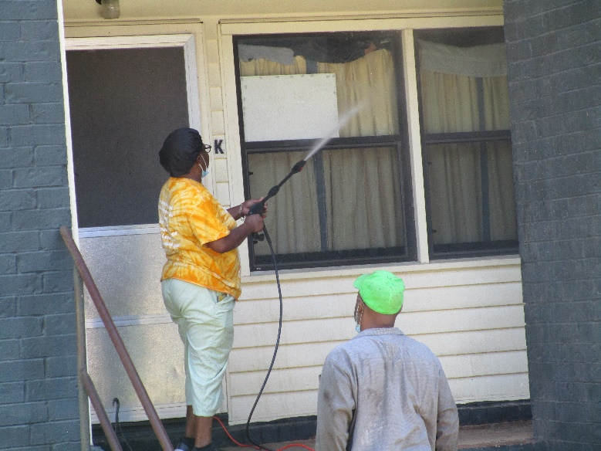
Cynthia & James Hunt pressure washed
their unit.

FORREST STREET RESIDENTS ROCK!!!

LET’S KEEP SWEEPING OUR NEIGHBORHOOD!!!
Page 7
HEALTH DEPARTMENT ON WHEELS
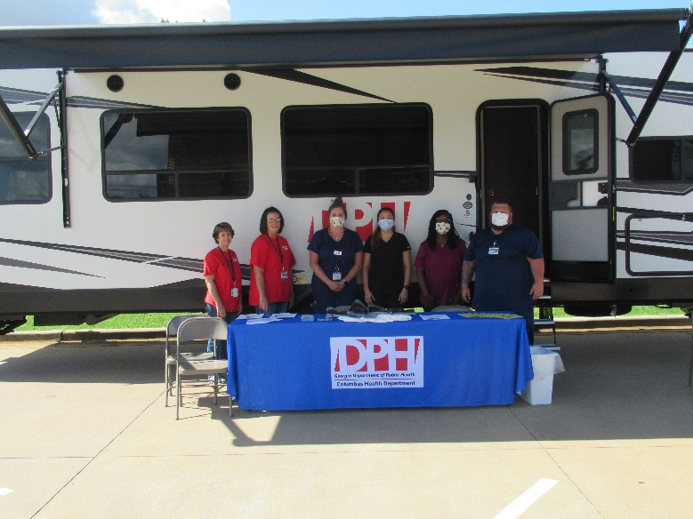
Staff Members from the Department of Public Health
(Columbus, GA affiliate)

The Department of Public Health (Columbus, GA affiliate) recently brought their Health Department services to the Housing Authority residents. It is part of their goal to “bring health services to the people”.

Andrea Gonzalez RN, performs a blood pressure check for Housing Authority resident Darrius Clemons.

Their Heath Department on Wheels (mobile health van) was located at our John C. Anderson Community Building. Services offered included but was not limited to the following: Vacinnations, Boosters, Blood Pressure Checks, COVID Home Test Kits, HIV Prevention Services, Child Health Services, Nutrition Education, and Substance Abuse Prevention Resources.
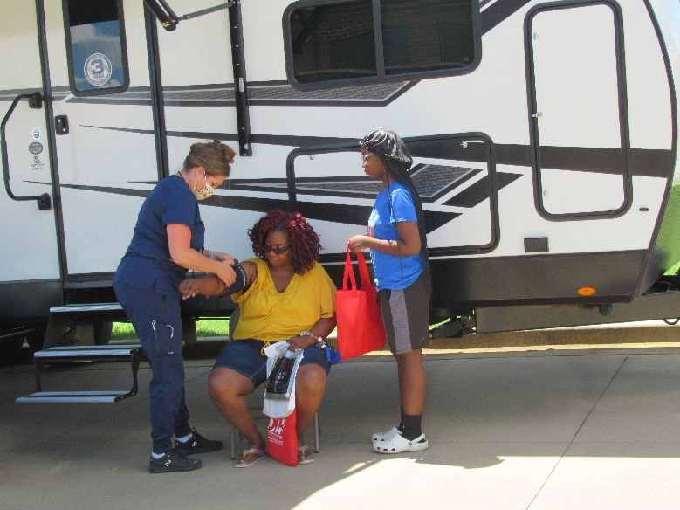
Ashley Pritchard RN, checks the blood pressure for Ms. Jamee Robinson. Her daughter, Samaria Robinson looks on.

The Health Department on Wheels will be coming to other housing areas. Diana Roberts, Resident Services Coordinator said all residents will be notified by mail as to the dates and times when the service will be available in each location.

********************************************
Health Department on Wheels Is Coming To Your Area

August 15th – Masonic Drive
(Across from Apt. 61B)

September 19th - Leslie Police Department
Parking Lot

October 17th – Barbara Battle Way

November 14th – Veranda Senior Complex

December 12th – Ridge/Douglas Street Area
(1213 Douglas Circle)

Time: 11:00 – 1:00 for all locations

Contact Diana Roberts at 924-3386, Ext. 240 for more information.
Page 8

RECIPE CORNER

CHEESEBURGER SLIDERS

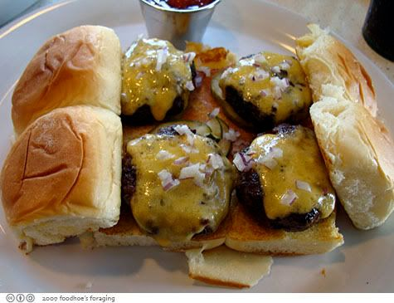

You will need:

1 egg slightly beaten ¼ teaspoon pepper
2 tablespoons ¼ teaspoon garlic powder
dill pickle relish 1 pound ground beef
2 tablespoons ketchup 1 sliced tomato
2 teaspoons 3-4 hamburger dill slices
Worchester sauce 3-4 slices
2 teaspoons American cheese
prepared mustard 10 dinner rolls, split

Preparation:

-In a large bowl, combine the first eight ingredients. Mix well.

-Shape into 10 patties.

-Grill 3-4 inches from the heat for 4-6 minutes on each side or until a meat thermometer reads 160 degrees.

-Cut cheese slices into thirds and immediately place on burgers.

-Add pickles and tomatoes.

Yield: 10 delicious cheese burger sliders

HERSHEY KISSES
PEANUT BUTTER COOKIES

You will need:

1 cup white sugar 2 ½ cups flour
1 cup brown sugar 2 tsp. baking soda
1 cup shortening 1 teaspoon salt
1 cup peanut butter Loose white sugar
¼ cup milk 120 milk chocolate
2 teaspoon vanilla kisses
flavoring (2 – 9 ounce bags)

Preparation:

*Pre-heat oven to 375 degrees.
*Combine white sugar, brown sugar, shortening, peanut butter, milk, vanilla, and eggs.
*Blend until smooth.
*Lightly spoon flour into cup; level off.
*Stir in flour, baking soda and salt. Mix well.
*Shape into 1 inch balls and roll in loose sugar.
*Place 2 inches apart on ungreased cookie sheet.
*Bake 8-12 minutes until light golden brown.
*Immediately top each cookie with an unwrapped kiss; press down firmly so cookie cracks around the edge.
*Bake 2 minutes longer.
*Remove cookies from baking sheet and cool immediately.

Yield: 2 dozen delicious Hershey Kisses
Peanut Butter Cookies
Page 9

MEET OUR
NEW MPLOYEES

The Americus Housing Authority is happy to announce the additon of three new employees.

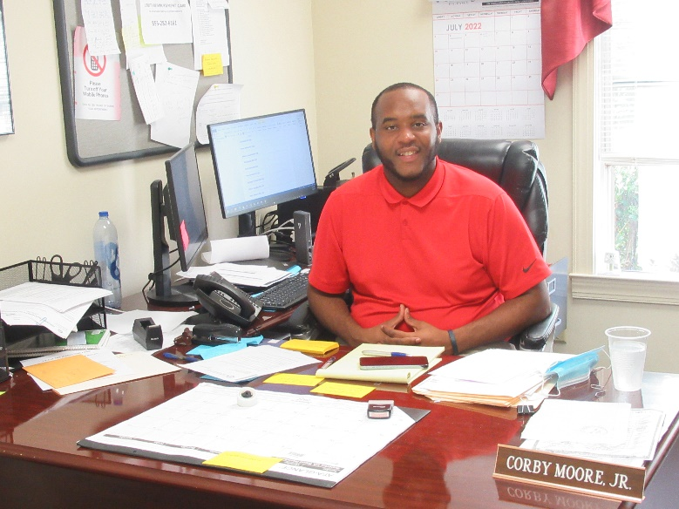
Corby Moore Jr.

Our HCV / RAD / Owned Assistant is Corby Moore Jr.. Corby resides in Americus. Many of you may know Corby from the local Recreation Department. He is currently pursuing a Bachelor of Science Degree in Sports Management. Corby enjoys working with kids and listening to music. Being an ultimate people person, Corby has easily embraced his daily interaction with our residents.
OTHER PERSONNEL CHANGES

Rachel Spencer (former Customer Service Representative) retired after
15 years of service to the
Americus Housing Authority.
HAPPY RETIREMENT Ms. Rachel!!!

Paula Harmon (former Occupancy Specialist for Public Housing) has joined our Finance Department as an Accounting Clerk. We wish Ms. Harmon the very best in her new assignment.

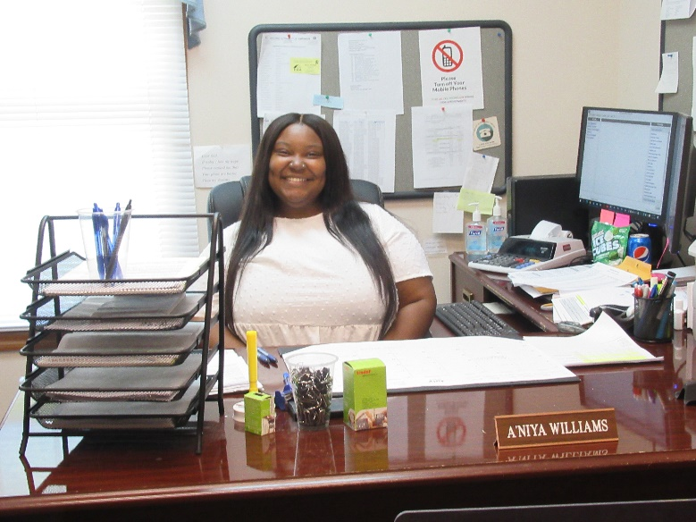
A’Niya Williams

A’Niya Williams is our new Occupancy Specialist. A’Niya is from Augusta, GA, by way of Fort Lauderdale, FL. She is a recent honor graduate from Southern University and A&M College in Baton Rouge, LA with a degree in Political Science. A’Niya replaces Paula Harmon who has joined our Finance Department. In addition to being family-oriented, A’Niya loves to travel in her off time. A’Niya looks forward to making Americus her new home.

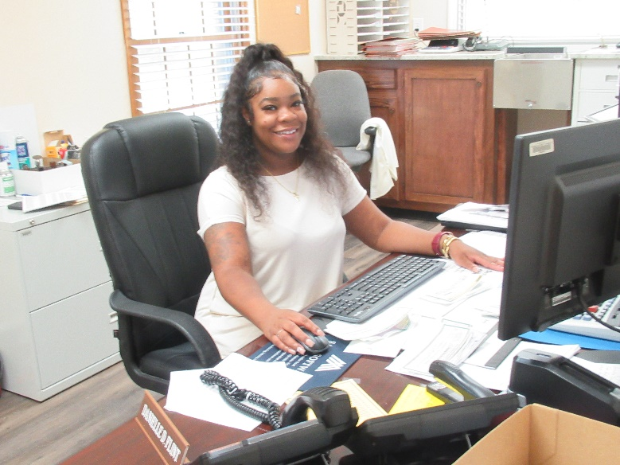
Danielle Flint

Danielle Flint is our new Customer Service Representative. Danielle replaces Ms. Rachel Spencer who recently retired. Danielle is from Americus and the mother of two children. Danielle is from a “big family” and she enjoys cooking and spending time with her friends. Being originally from Americus, Danielle looks forward to being able to give back to her community through her new position.
She also wants to continue providing great customer service to our residents.
Page 10

WE ARE HERE TO SERVE YOU
Main Office Number (229) 924-3386
7:30 a.m. – 5:30 p.m.
Monday thru Thursday

CLOSED ON FRIDAYS

WE HAVE MADE SOME CHANGES IN OUR STAFF
TO BETTER SERVE YOU!!!

ADMINISTRATIVE STAFF
Danielle Flint(Customer Service Representative) – Ext. 210
Cherryl Fulow (PH/HCV Compliance Officer) – Ext. 221
Katina Garrett (Project Manager, Public Housing) – Ext. 220
Paula Harmon (Accounting Clerk) – Ext. 243
Terry Harris (Section 8 Case Manager) – Ext. 216
Sharon Haugabook (Project Manager, Public Housing) – Ext. 215
Gwen Laster (Case Manager – HCV) – Ext. 218
Corby Moore Jr. (HCV/RAD/Owned Assistant) – Ext. 245
Gail Watkins (Housing Inspector for Section 8) – Ext. 222
A’Niya Williams (Occupancy Specialist) – Ext. 217

CHIEF EXECUTIVE OFFICER
George F. Edge, CEO, Ext. 211

DEPARTMENT HEADS
Shelia DeLoach (Manager of Finance) – Ext. 241
Penny McPeek (Manager of Housing) – Ext. 214
Gary Woods (Manager of Technical Services) – Ext. 213

RESIDENT SERVICES DEPARTMENT
Diana Roberts
(Resident Services Coordinator) - Ext. 240

MAINTENANCE DEPARTMENT
(229) 924-9073 / Direct Line
Bernice Johnson (Maintenance Clerk) – Ext. 225

SOUTHLAND HEIGHTS APARTMENTS
Cheryle Henry (Site Manager)
(229) 924-4253
Page 11

PRSRT STD
U.S. POSTAGE PAID
AMERICUS, GEORGIA 31709
PERMIT #447

Our corner is a quarterly publication of the: Housing Authority of Americus
825 North Mayo Street
Americus, Georgia 31709

CEO............................ George F. Edge
Managing Editor, Writer,
Photographer ............ Diana H. Roberts
Board of Commissioners:
Bobby L. Fuse Jr. G. Bardin Hooks, Jr.
Ricky Arnold Dwight Chavis
Jessica Wright Bill Krenson

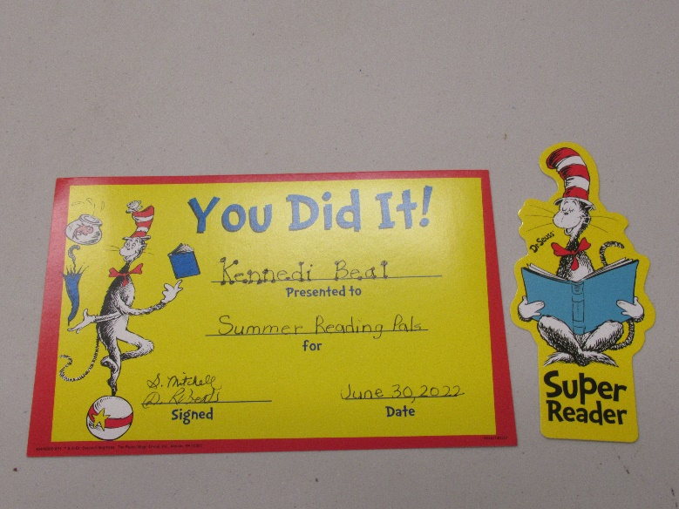

CURRENT RESIDENT OR

