RIDGE WOODS SUBDIVISION
- - OUR CORNER- -
THE HOUSING AUTHORITY OF AMERICUS NEWSLETTER
“Building Bridges For Better Communication”

JULY 2022

“Where Homeownership Becomes
A Reality”

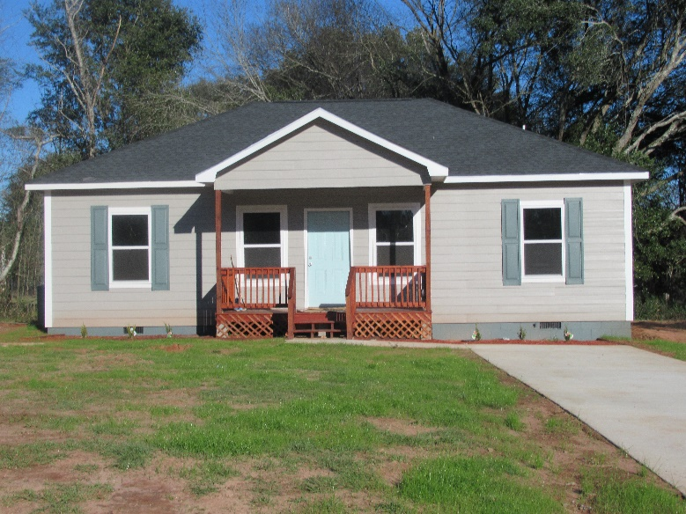
Home nears completion.

Construction is nearing completion on the first group of houses located in Ridge Woods Subdivision. Shrubbery is in place, driveways are poured, and grass has been planted.

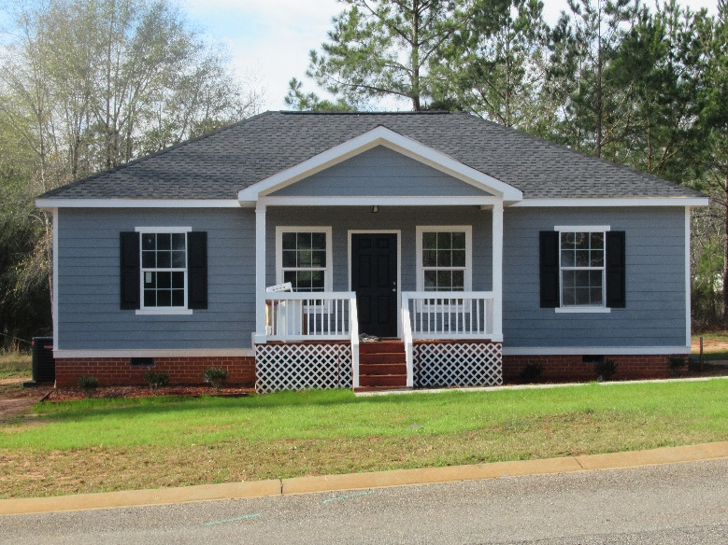
Home nears completion.

In addition to the homes shown here, another home is underway as well, with the foundation already in place.

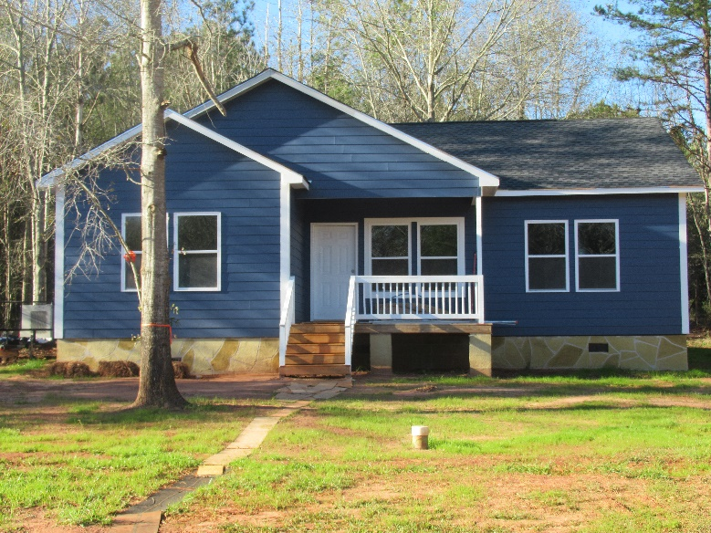
Home nears completion.

There are approximately 15 more lots that have not been obligated for sell. Each lot is approximately 1/3 of an acre in size. Each conventional home will consist of 3 bedrooms, 2 baths, and many other amenities.

We would love to have you and your family join the four families that are already calling Ridge Woods Subdivision their new home. The Housing Authority of Americus is excited about adding 19 new conventional homes to the Americus, Sumter County area. This opportunity for homeownership is available to any and all of our Housing Authority of Americus Resident Affiliates (Public Housing, Section 8, Owned, and Southland Heights).

Please contact Mrs. Diana Roberts in Resident Services for more information @ (229) 924-3386, Ext. 240.

RIDGE WOODS SUBDIVISON

“Where HOMEOWNERSHIP
Becomes a reality”
HAPPY NEW YEAR

Mr. George F. Edge, Chief Executive Officer

We are off and running at an accelerated rate of speed into this New Year. We have completed the RAD (Rental Assistance Demonstration) for our apartments located in Andersonville, Plains, and Leslie. I want to send out a special THANK YOU to the residents who reside in these areas for your cooperation in the conversion process.

Now we are on the verge of converting both Eastside and Northside. Eastside consists of Tripp, Harris, Fairfield, Cherokee, Hanson, Dixon, Lakeview, Douglas, and Ridge Streets. Northside consists of Reddick, North Jackson, Masonic, Brinson, North Lee, Barbara Battle Way, Bozeman, Brookdale, Burton, and Benjamin Streets. You will be required to sign a new dwelling lease, because your Public Housing lease will be terminating the month prior to the conversion date. We will be notifying you of your appointment date and time to come into the office to execute your new RAD Lease Agreement.

In accordance with your lease agreement, it is your responsibility to keep the property clean and well maintained. I am encouraging all residents to help keep your neighborhoods clean and free of litter. The neighborhoods look so much better when this takes place. We will be issuing the lawn maintenance contracts in a few months, and we want the grounds prepared when they begin cutting.

Also, the Housing Authority of Americus has a Porch Policy. Only “outside” furniture is allowed to be permanently kept on your porch. However, it must be furniture constructed for “outdoor” use. No other furniture may be kept outside. If “inside” furniture is brought outside to be used for a particular gathering, it must be removed from the outdoors when such gathering ends. “Inside” furniture left outside unoccupied will be considered as a violation against this policy.

Also, the following items are not allowed to be stored or abandoned in the yard: tires of any sort, batteries, bicycle parts, automobile parts, buckets, aluminum cans, grocery carts, shelving, and bedroom furniture such as mattresses, box springs, frames, head and foot boards and dressers. Painting the concrete floor area of the front and back porches is also not allowed.

Finally, due to the rise in positive COVID test results in Sumter County, and in an effort to keep our employees and you (our residents) safe, we are asking the following:

- If you or a member of your family are in quarantine, PLEASE DO NOT REPORT maintenance work orders except for extreme emergencies. Extreme emergencies are defined as water leaks, drain backups, electrical issues such as shortages, air conditioning if the temp is above 90 degrees inside the apartment in the summer; and 40 degrees or below in the winter.

- If you have traveled and are not feeling well, PLEASE DO NOT REPORT maintenance work orders except for extreme emergencies.

For any and all other maintenance requests, please wait until your household has been released from quarantine.

Further, I want to encourage you to continue to wash your hands often. Use soap and water for at least 20 seconds; especially if you are in a public place, or after blowing your nose, coughing, or sneezing.

Please stay safe!!

George F. Edge, CEO
“Without you there will be no me.”
Page 2

GREETINGS FROM THE
HOUSING DEPARTMENT
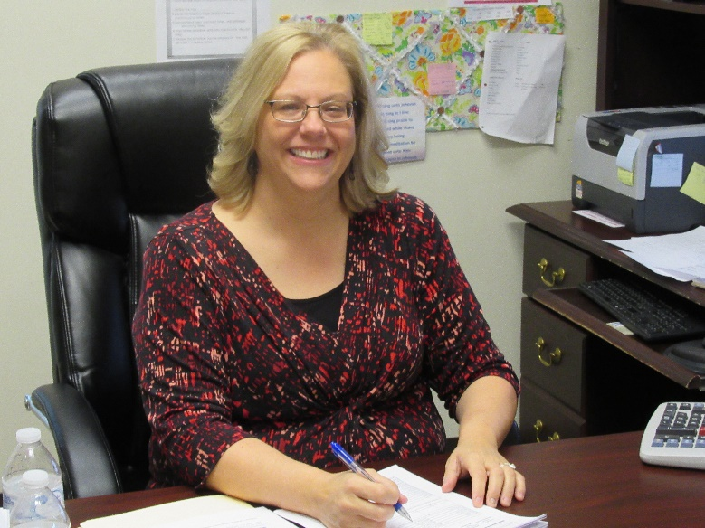
Mrs. Penny McPeek, Manager of Housing

Hello All:

In November, a letter was sent out listing the major changes the RAD program would bring. Such as:
- Rent will be due on the 5th of every month. A $5.00 late fee will be added on the 6th; and $1.00/day thereafter.
- All income changes must be reported to the Housing Authority within 10 days of occurrence.
- All tenants must be in the correct unit size for the number of people listed on their lease agreement. If you do not move when requested to do so by the Housing Authority; you will be required to pay a higher rent in order to stay in a larger unit.
- If you do not complete your Annual Recertification on time, your assistance will be terminated. You will then have to pay Market Rent until your Recertification is complete or until you move out.
- EID is no longer available if you are not on it currently.
- Flat/Ceiling rents are no longer available. If you are on Flat/Ceiling rent currently, your rent will increase in increments for the next 3 rent changes until the full 30% of your income is reached.

Please refer to your November letter for full explanations and more details. This list is not exclusive. It is important that you read all the paperwork that you were given to take home at your RAD lease sign up meeting.

However, there is one change that was not mentioned.
- We are no longer allowed to transfer tenants from one Property Site to another. Our RAD program is divided into 3 Property Site Names. They are Eastside, Northside, and Scattered Sites (Andersonville, Leslie, and Plains). Tenants may ask for transfers within their current Property Site. However, if a tenant wants to move to a different Property Site, they will need to complete a new application for that Property Site. Currently, applications are closed. The Housing Authority Website and Facebook page will have an announcement when the applications are open.

Thank you for your cooperation as we go through this Program change.

Penny McPeek
Manager of Housing

+++++++++++++++++

THE IMPORTANCE OF
YOUR CREDIT SCORE

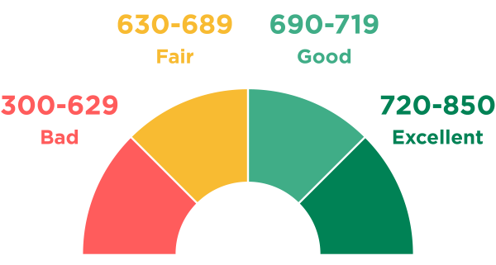

A good credit score isn’t something you achieve overnight. You have to invest in your credit. Getting a good credit score is a great achievement! It can help you qualify for the credit you need at the lowest possible interest rates. Once you get there, it is important to stay vigilant to maintain your good credit standing.

Page 3
FREE FOOD
DISTRIBUTION
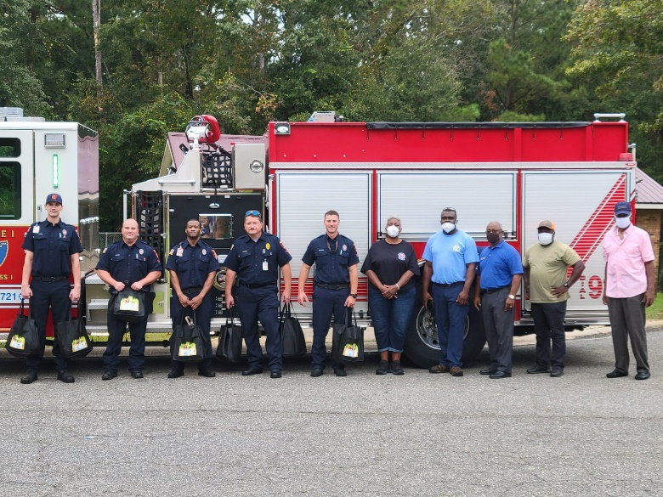
Members of the Americus Fire Department, Housing Authority Employees, and City Councilman Nelson Brown

The Americus Housing Authority has partnered with Healthy Sumter & Flint River Fresh to deliver fresh bags of fruit and vegetables to all residents of the Americus Housing Authority.

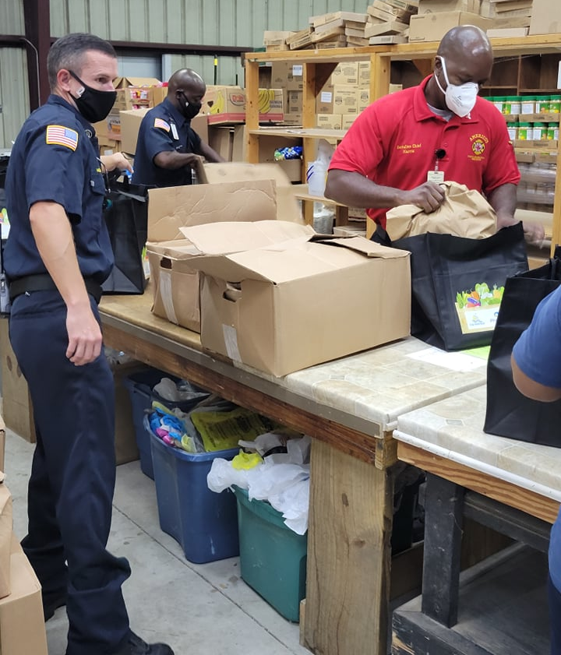
Volunteers from the Americus Fire & Emergency Services Station

The free food distribution took place every two weeks from August to November of 2021, at which time a break was observed for the holidays. Distribution is expected to start back up in February.

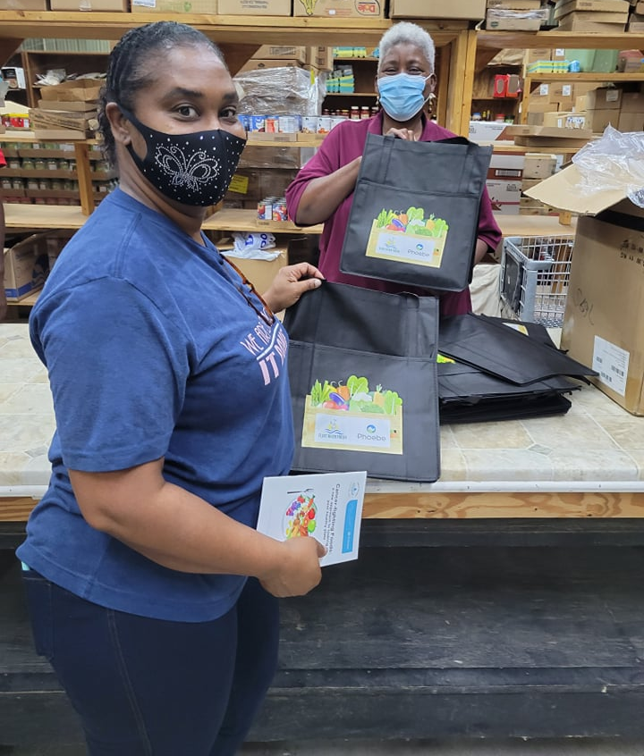
Ms. Katina Garrett (Public Housing Project Manager) & Mrs. Diana Roberts (Resident Services Coordinator)

Approximately 260 families and 600 residents have already been serviced by this initiative. Distribution areas are randomly selected by the Housing Authority.

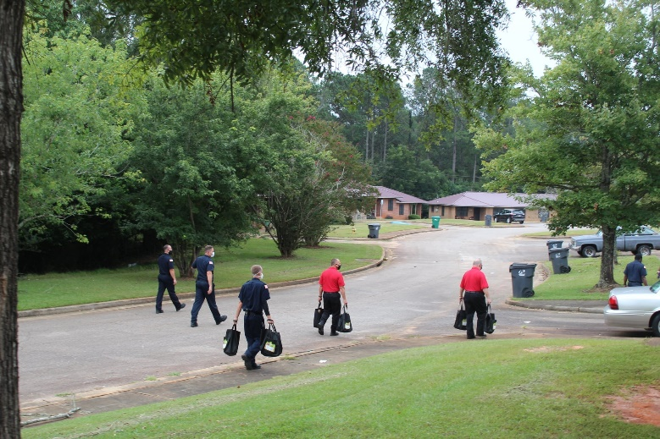
Firemen begin door-to-door distribution of food bags

Page 4

This free food distribution is part of Phoebe Sumter’s initiative to address Food Security in Americus & Sumter County; as well as in neighboring counties. Other initiatives will include creating community gardens and teaching people how to create gardens at their own home.

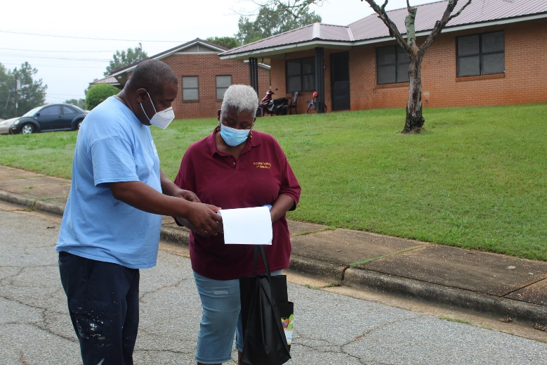
Mr. Johnny Durham (Housing Authority Maintenance Mechanic & Working Foreman) discuss distribution route with Mrs. Roberts

On behalf of the Americus Housing Authority, Mr. George Edge extends special thanks to Mr. Marcus Johnson of Phoebe Sumter, Farmer Fredo Jackson, Councilman Nelson Brown, volunteers from the Americus Fire Department as well as the Americus Fire & Rescue Emergency Stations for making this opportunity available to our residents. Also, special thanks to Mr. Sonny Pinckard, Mrs. Ginger Pinckard and the staff of Harvest of Hope for allowing the use of their facility for storage.

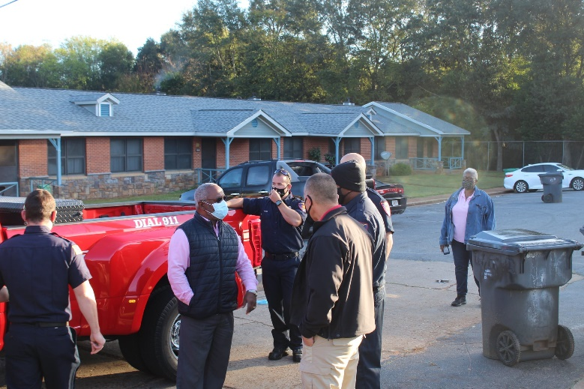
Mr. George Edge speaks with members of the Americus Fire
Department following a Site Distribution

To all Housing Authority residents who have not been serviced as of yet; know that we will be coming to your areas in 2022. You will be receiving a flyer to notify you of the dates and times.
Help For Managing
Multiple Medications

If dealing with multiple medications is a daily challenge for you or a loved one, you are not alone. Nearly 40% of all adults take five or more prescription drugs daily. The best approach: When using several medications, be proactive. These strategies can make managing multiple medications easier and safe.

Fill Your Prescriptions at One Pharmacy
This makes getting prescription refills simpler- so you are more likely to take medications as directed. It also helps your pharmacist protect you from drug interactions.

Use a Pill Dispenser or Other Reminder System
A pill box with compartments for each day of the week- and for morning, noon and night if you take medications several times a day- lets you know at a glance whether you have taken your medicines or not.

Get Prescriptions Refilled Early
Running out of your medicines could allow health conditions to worsen. Check expiration dates frequently and discard any medicines that are out of date. Your pharmacist may even be able to help you get multiple medications on the same refill schedule so that you can make fewer trips to the drugstore.

Make a List and Update it Regularly
Make a list of the medications you take- with the name of the drug, the dose, how often you take it and why. Put a copy in your medical files at home, carry one in your wallet to show your doctor, and give a copy to a loved one or friend in case you have a medical emergency.

Page 5
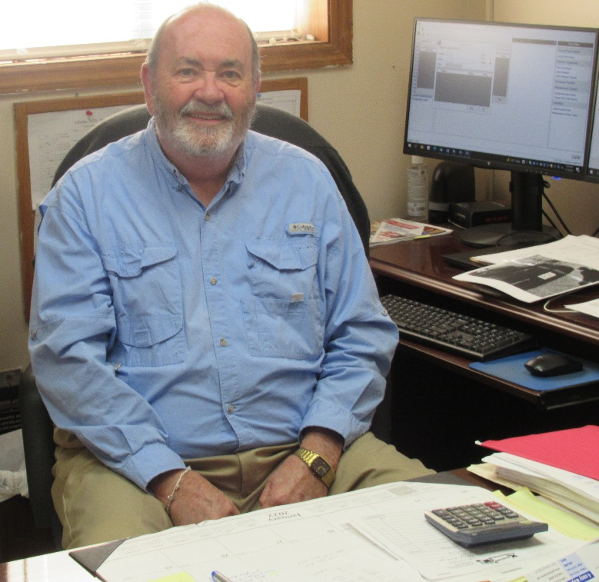
Mr. Gary Woods, Manager of Maintenance

HELLO from the Maintenance Department and HAPPY NEW YEAR to all!!! We have entered into the throes of winter. I want to offer the following suggestions in an effort to safeguard your family and to save you some expense.

- Keep your thermostat set to 68 degrees.
- Keep all doors and windows closed.
- Be sure your smoke and carbon monoxide detectors are in good working condition.
- If either your smoke or carbon dioxide detector “begins beeping, it just needs the battery changed. DO NOT REMOVE THE DETECTORS!! The Maintenance Department will change the battery for free.
- If you smell natural gas, exit the home immediately and call 911 for the Fire Department.

The Housing Authority is changing the heating and air conditioning systems in 191 units in various areas. These changes will equip all units with the most modern and efficient systems available. We will also continue to renovate bathrooms, kitchens, etc.

Remember that the Maintenance Department is here to help you in any way that we can. Do not hesitate to call when anything, no matter how insignificant you may think the issue is, goes wrong. That will keep small issues from getting to be large issues. It is our goal to make your home as comfortable and carefree as possible. To each of you, I hope you have a great year 2022. Stay safe!!
FREE At-Home COVID-19 Tests Available
NOW via Postal Service
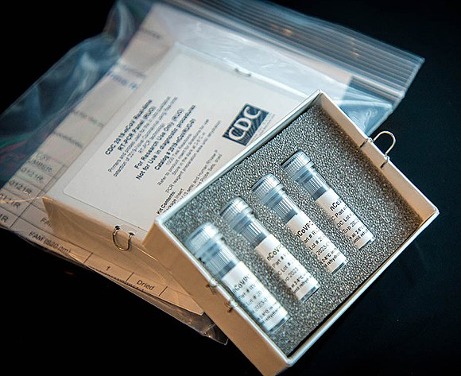

Every household in the U S. is eligible to order 4 FREE at-home COVID-19 tests:

Help families in your community get their tests now so they will have them when they need them.

The tests are completely FREE, and orders placed today will usually ship by the end of the month.

If anyone needs a COVID-19 test now, please see other testing resources for free testing locations in your area.

The tests available for order:

- Are rapid antigen at-home tests, not PCR

- Can be taken anywhere (no drop-off required)

- Provide results in 30 minutes or less

- Work regardless of any COVID-19 symptoms
DID YOU KNOW: Smallpox, which once killed 3 in 10 of its victims, was declared eradicated (completely removed & destroyed) in 1980? The disease no longer poses a threat because of near-universal vaccination.
Page 6

PET POLICY
(These do not apply to animals
that aid the handicapped)

NOAH ROBERTS

Common household pets shall be confined to:
- Dogs under 20 pounds
- Cats
- Fish commonly kept as pets
- Caged birds (not domestic foul)
- Hamsters, turtles & Guinea pigs

PET DEPOSITS
Owners of dogs and cats shall be required to pay a $250.00 Pet Security Deposit in addition to any deposit required by the lease. The deposit for seniors is $100.00. Refund of this Pet Security Deposit shall be handled as outlined in the Dwelling Lease. Management will determine the method and time for payment of this pet deposit.

PET REGISTRATION
Each pet owner shall register his or her pet with the Housing Authority prior to moving into the apartment. Pet registration shall be updated at least annually at the time of the owner’s re-examination.

CAPABILITY OF PET OWNERS
Pet owners shall demonstrate the physical, mental, and financial capability to care for a pet.

REMOVAL OF PETS
A pet must be removed when:
- A pet become vicious,
- A pet becomes a nuisance,
- The pet’s owner becomes unable or unwilling to care for or control the pet,
- Federal, State and Local laws and/or regulations are not met.
OWNER’S RESPONSIBILITIES
- Pet owners shall resume full responsibility for any vicious or destructive act by the pet.
- Pet owners shall be responsible for abiding by all Federal, State and Local laws and regulations as they may be changed from time to time.
- Pet owners agree to immediately remove a pet which has been determined to be vicious by management or the local authority – until such time as a decision may be reached by agreement or by a grievance hearing.

NON-COMMERCIAL PROVISIONS
No pet shall be raised, bred, kept, or trained for any commercial purpose.

PET AND NO-PET AREAS
Animals shall not be allowed in the following areas designated “NO-PET” areas: Nutrition Sites, Community Services Buildings, Project Offices, and Recreation areas.

*******************

400 MILLION N95 MASKS
AVAILABLE FOR FREE
The White House has made 400 million N95 masks available for free as part of a string of actions aimed at fighting the surging omicron variant.

The N95 masks will be shipped to pharmacies and community health centers across the country, where they will be available for people to pick up for FREE. Three (3) masks will be available per person.

The Center for Disease Control and Prevention (CDC) states that N95 masks offer the highest level of protection.

The masks are now available. Please check with your local pharmacies and community health centers to inquire about the FREE N95 masks.
Page 7

EMPLOYEE SERVICE
AWARDS
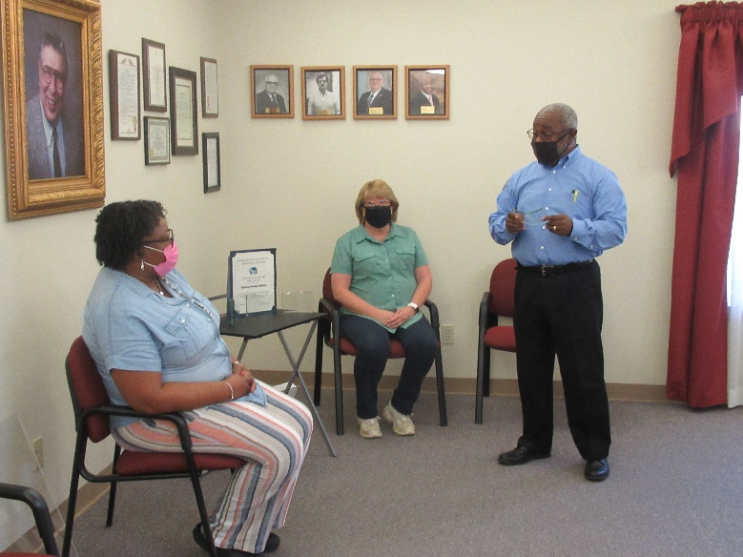
(L-R) Ms. Cherryl Fullow, Mrs. Paula Harmon, Mr. George Edge

Service awards were recently presented in recognition for 20 or more years of dedicated service to the Housing Authority of Americus. The 2021 Service Awards were given by the Georgia Association of Housing and Redevelopment Authorities, and then presented in-house by Mr. George Edge, CEO of the Americus Housing Authority.

Ms. Cherryl Furlow joined the Housing Authority of Americus workforce in 2000 as a Customer Service Representative. She later transitioned to the position of Section 8 Case Manager. Currently, Ms. Furlow holds the position of Public Housing/Housing Choice Voucher (PH/HCV) Compliance Officer.

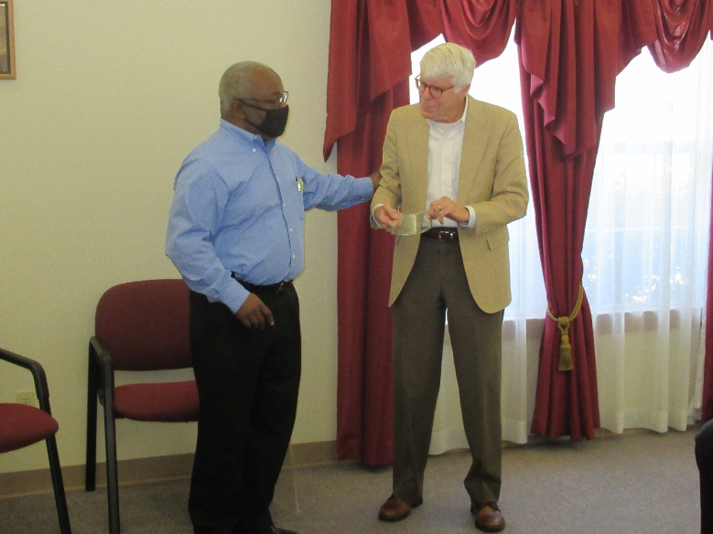
Mr. George Edge & Mr. Bill Krenson
Mrs. Paula Harmon joined the Housing Authority of Americus workforce in 2001 as a Customer Service Representative. Her next position was that of Public Housing Case Worker. Currently, Mrs. Harmon is the Occuprancy Specialist for our Public Housing Program.

Mr. Bill Krenson has been a part of the Housing Authority Board of Commissioners for 25 years. Mr. Krenson served as Chairman of the Board of Commissioners for seven years; from 2005 to 2012.

(L-R) Mr. Dwight Chavis (Resident Commissioner), Mr. Bobby L. Fuse (Board Chairman), Mrs. Paula Harmon, Ms. Cherryl Furlow, Mr. George F. Edge (CEO), Mr. Bill Krenson, and Mr. Ricky Arnold (Commissioner)

Mr. Bobby L. Fuse, Chairman of the Board of Commissioners joined Mr. Edge in expressing his gratitude to Ms. Furlow, Mrs. Harmon, and Mr. Krenson for their input in making the Housing Authority of Americus run smoothly on a daily basis; as well as in making the Housing Authority of Americus a high performing Housing Authority in the State of Georgia.
Page 8

RECIPE CORNER
QUICK BEEF CHILI

You will need:

-1 tablespoon vegetable oil
-1 ½ pounds lean ground beef
-1/2 cup chopped onion
-1 envelope (1 ¾ ounces) chili seasoning mix
-1/2 cup water
-1 can (14.5 ounces) diced tomatoes, undrained
-1 can (15 ounces) kidney beans, undrained
-1 tablespoon brown sugar

Preparation:
-Heat oil in a large, heavy skillet.

*Cook ground beef and onions over medium heat until no longer pink.

*Stir in chili seasoning mix, and then add remaining ingredients.

*Bring to a boil. Reduce heat, cover, and simmer for 10 minutes.

*Serve with cornbread or crackers of choice.

Yield: 6 servings

(This chili can be spiced up with hot ground pepper, Manwich sauce, chopped jalapeno or mild chilies, cilantro, or other favorite ingredients.)

HONEY-LEMON GINGER TEA

You will need:

-4 cups water
-3/4 cup brown sugar
-1/4 cup grated ginger root
-3 tea bags
-2 lemons, juiced
-3 tablespoons honey

Preparations:

Step 1
Stir water, brown sugar, and grated ginger root together in a saucepan; bring to boil, reduce heat to medium-low, and cook at a simmer for 20 minutes.

Step 2
Remove saucepan from heat and add tea bags; steep tea to desired strength, 3 to 5 minutes. Remove and discard tea bags.

Step 3
Stir lemon juice and honey into the tea; strain into a pitcher.

Yield: 6 servings

Some Benefits of Ginger Tea:
*Soothes the Stomach
*Boosts Your Immune System
*Protects Brain Health
PAGE 9
*Fights Colds and Sore Throats
*Helps to Lower Blood Pressure
*Helps Prevent Heart Attacks
*Anti-inflammatory
*Eases Headaches and Migraines
*Antioxidant Rich

HOUSING AUTHORITY WELCOMES
NEW MAINTENANCE EMPLOYEES

The Housing Authority of Americus is pleased to announce the addition of two new employees to our Maintenance Department. We ask that you join us in welcoming them into the Housing Authority Family when they are providing maintenance service in your area.

The Housing Authority of Americus is so proud to add two technicians to our Maintenance Department with the work experience that Charlie Myers and Harold Pope II already possess. With the current state of our economy, the job market is an open field for job seekers. Acquiring these two Maintenance Mechanical Assistants was no easy task. However, it is always the intent of the Housing Authority to acquire the best employees possible to serve the needs of our residents.

Both Charlie and Harold have made a positive impact in our Maintenance Department; not only with their job skills but with their pleasing personalities. So go ahead and give Charlie and Harold a big WELCOME ABOARD when you get to meet them.

Charlie Myers (Maintenance Mechanical Assistant)

CHARLIE MYERS comes to us with a wide array of maintenance skills already intact. Charlie was previously employed in Ellaville. Currently, Charlie and his wife make their home in Americus with their daughter and two sons.
Harold Pope II (Maintenance Mechanical Assitant)

HAROLD POPE II is a former employee of Tyson Foods. Harold says he is always “Poppin Out With The Popes”. Harold and his wife (still newlyweds) make their home in Americus and they are the parents of one son. Harold is quite familiar with the maintenance work arena from previous jobs.

**************************************
COMING TOGETHER
is a beginning.

KEEPING TOGETHER
is progress.

WORKING TOGETHER
is success.
Page 10

WE ARE HERE TO SERVE YOU
Main Office Number (229) 924-3386
7:30 a.m. – 5:30 p.m.
Monday thru Thursday

CLOSED ON FRIDAYS

“Customer Service is an attitude and not a department.
YOU are the reason that we are here.”

ADMINISTRATIVE STAFF
Cherryl Fulow (PH/HCV Compliance Officer) – Ext. 221
Katina Garrett (Project Manager, Public Housing) – Ext. 220
Paula Harmon (Occupancy Specialist for Public Housing) – Ext. 217
Terri Harris (Occupancy Specialist – HCV) – Ext. 216
Sharon Haugabook (Project Manager, Public Housing) – Ext. 215
Gwen Laster (Case Manager – HCV) – Ext. 218
Jan Olek (Accounting Clerk) – Ext. 243
Rachel Spencer (Customer Service Representative) – Ext. 210
Gail Watkins (Housing Inspector for Section 8) – Ext. 222

CHIEF EXECUTIVE OFFICER
George F. Edge, CEO, Ext. 211

DEPARTMENT HEADS
Shelia DeLoach (Manager of Finance) – Ext. 241
Penny McPeek (Manager of Housing) – Ext. 214
Gary Woods (Manager of Technical Services) – Ext. 213

RESIDENT SERVICES DEPARTMENT
Diana Roberts
(Resident Services Coordinator) - Ext. 240

MAINTENANCE DEPARTMENT
(229) 924-9073 / Direct Line
Bernice Johnson (Maintenance Clerk) – Ext. 225

SOUTHLAND HEIGHTS APARTMENTS
Cheryle Henry (Site Manager)
(229) 924-4253

Page 11

PRSRT STD
U.S. POSTAGE PAID
AMERICUS, GEORGIA 31709
PERMIT #447

Our corner is a quarterly publication of the: Housing Authority of Americus
825 North Mayo Street
Americus, Georgia 31709

CEO............................ George F. Edge
Managing Editor, Writer,
Photographer ............ Diana H. Roberts
Board of Commissioners:
Bobby L. Fuse Jr. G. Bardin Hooks, Jr.
Ricky Arnold Dwight Chavis
Jessica Wright Bill Krenson

CURRENT RESIDENT OR

REMEMBER TO MOVE YOUR CLOCKS FORWARD
ON SUNDAY,
MARCH 13th.

